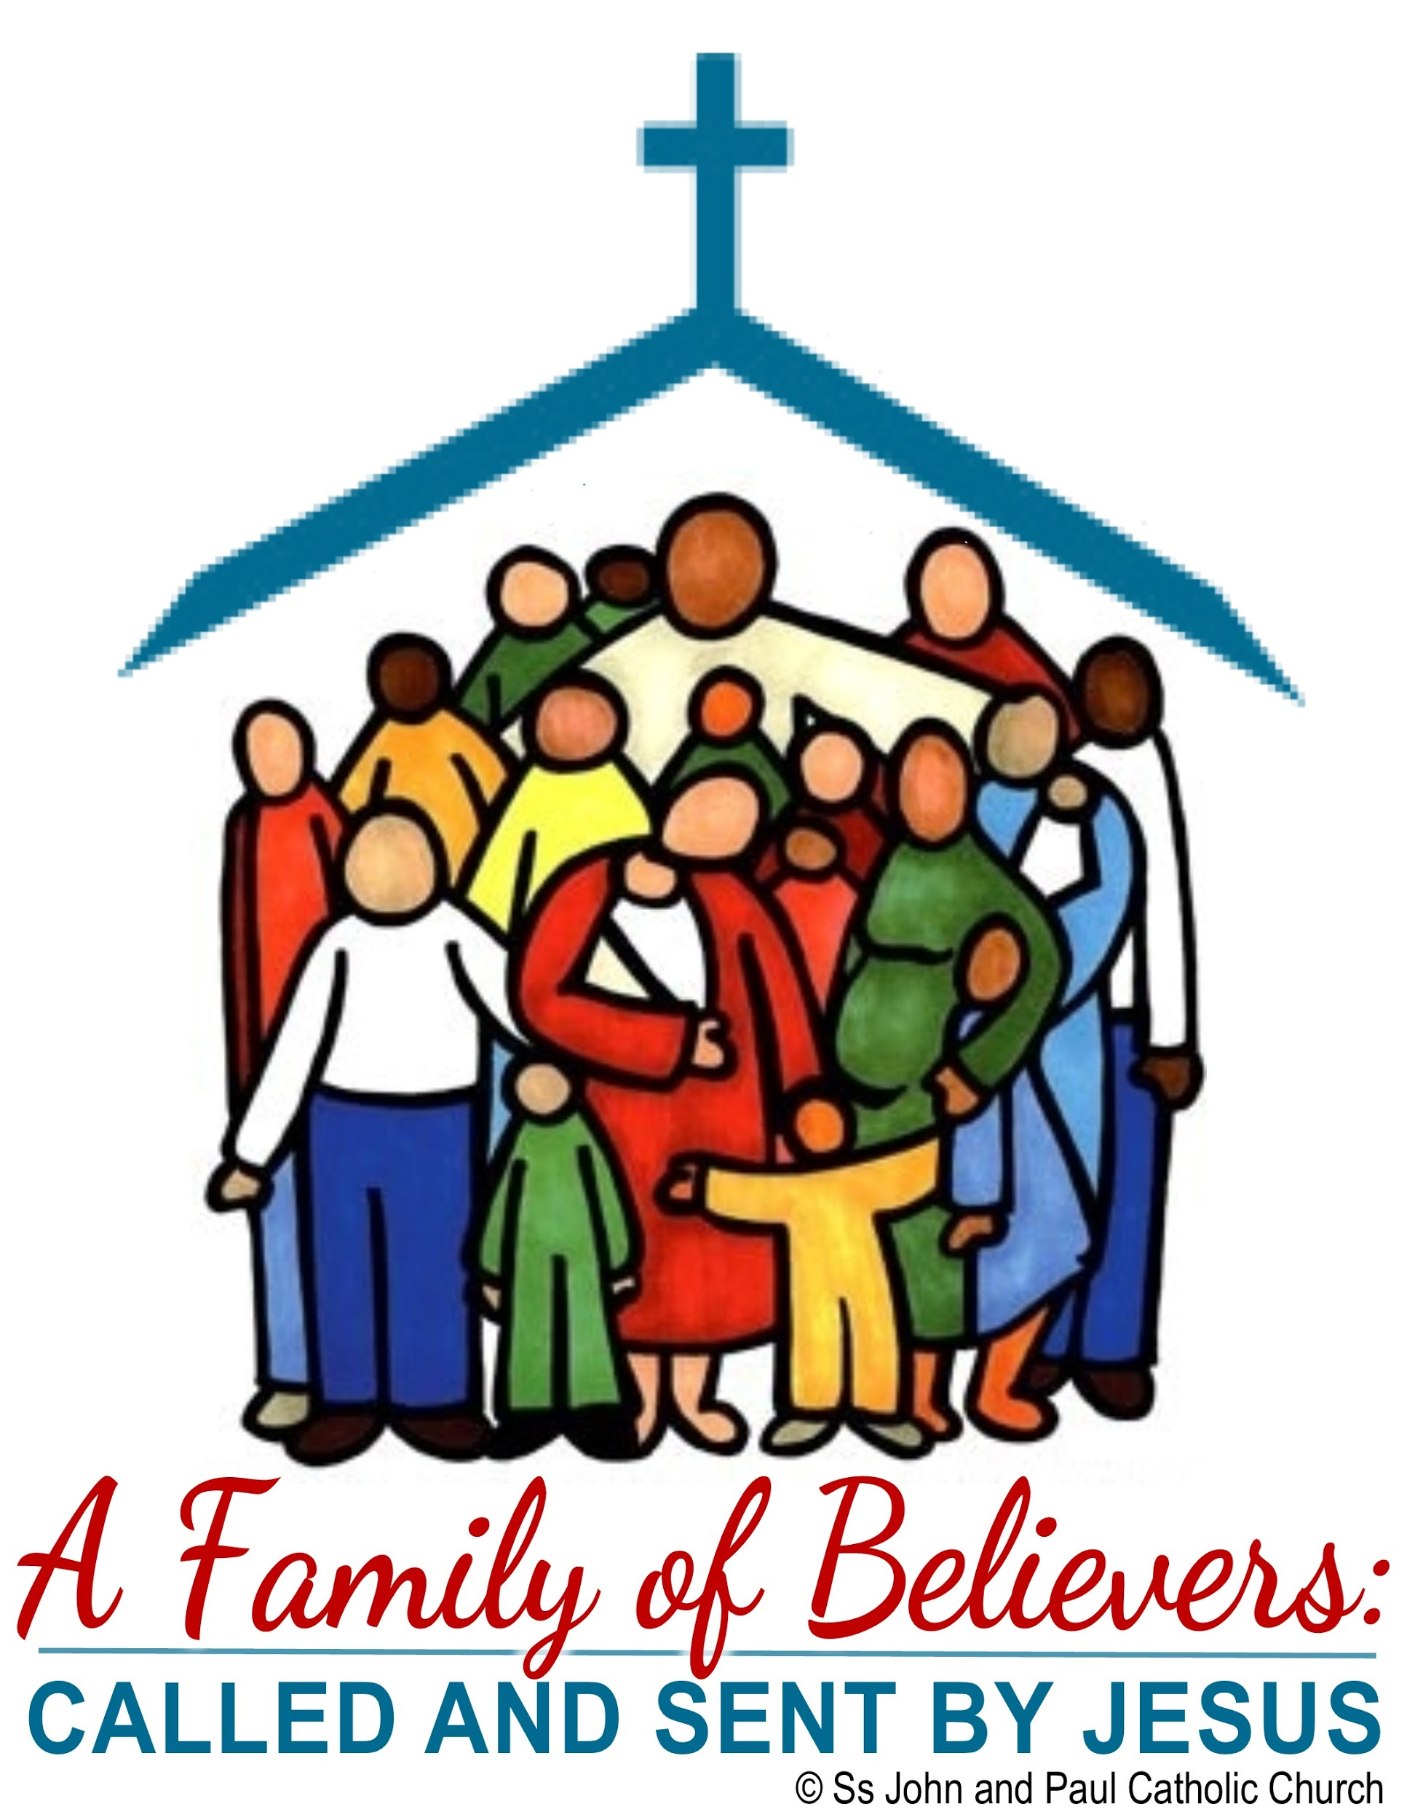
A Family of Believers: Called and Sent by Jesus
Parish Intergenerational Faith Formation
Ss. John & Paul Parish, Altoona, IA
Kitchen Table Faith Playlist
September 2020
In the Beginning 2.0

Summary: We begin our focus on domestic church, drawing upon stories of household churches in the New Testament.

Scripture Focus of the Month:
Acts of Apostles 2:42-47
Acts of Apostles 4:32-37

September Goals for the Month:
- To discover our households as domestic churches
- To begin to explore the New Testament
- To explore similarities between our households and those of the early Christian Church
- To create or refresh a prayer space in our households

Main Course
Faith Formation L!VE: 30-45 minute online gathering of households. The recording will be posted after the session.

Adult Faith Formation L!VE:

Sunday Gospel Reflections:

Parish Connection:(feedback, connection, google form, picture):
Household Poster Picture: Each household will make a poster with a word or phrase that characterizes their family. Take a picture of all the members of your household with your poster, and email it to ssjohnpaul@ssjohnpaul.org Staff will create a slideshow to share the posters and introduce each household. Watch for the slideshow to see familiar faces and other households’ words for the year. ​

Side Dishes
Household of Believers:

With Children
Beginning Family Church
Bible Basics:This year as we continue our study of the Bible and learn more about the New Testament, let's take a minute to review how we find Bible passages. We look them up by book of the Bible (check in the table of contents to find where each book begins). The first number is the chapter. The number after the colon is the verse or verses. Practice looking up verses. One person open the Bible and write down a verse you like. Give your verse to the person to your right and see if they can find the verse. See how many you can get correct. Happy learning.

Bible Story:
During Faith Formation this year we will be learning more about the New Testament. In the New Testament we will hear many stories about Jesus and the teachings of Jesus. Each month we will read a new story about Jesus. As you hear more stories about Jesus, you will build a relationship with him.
This month look up Matthew 7:7-11
Read the story from Matthew about asking God for what you need.

When you ask God for help, he will help. It may not always be the help you want. Jesus teaches us that God will always be there to hear our prayers and answer them. God will give us the things that are good for us.

What are some things you have asked your parents for?
Did they give them to you?
Did they make you wait?
Did they give you something better?

God answers prayers in the same way. Sometimes he gives us what we want, sometimes he gives us something even better and sometimes we just have to wait.

Object Lesson:Jesus gets excited when we pray
http://antidotesformom.blogspot.com/2013/07/childrens-ministry-jesus-gets-excited.html?m=1

Gather a few materials and have a little science fun while talking with your children about how Jesus feels when we pray to him or talk to him.
You will need:
-2 clear glasses filled with water
​-2 drops food coloring in each glass
-"Alka Selzer" type tabs (you can get them cheaply at the Dollar Tree)
-paper towels or tray to catch "fizz"

Gather your household around the glasses. Drop a tablet in the glass and watch the reaction. How did that make you feel? (Happy, excited, surprised. The excitement on their faces should be pretty evident.)

Connect this excitement to prayer. When we talk to Jesus in prayer this is how he feels. Jesus is excited when we pray with him and become friends with him. The more you know Jesus the more excited he gets and the more excited you get. Jesus loves us so much he wants nothing more than to be part of our lives.

Now you will each get a turn to pray to Jesus and drop a tablet into the glass to see the fizz. Let everyone know they will take turns praying for someone or asking for prayers and then they will get to drop a tablet into the cup. Let them know if they don't want to pray out loud that is ok. Silent prayers in our hearts are heard by Jesus just as much as prayers we speak out loud.
One make sure you listen very carefully, if you are quiet you can hear the fizz. Sometimes we have to be quiet and listen to hear Jesus.

Jesus My Friend: This year as we explore the New Testament we will learn more about Jesus. Jesus my friend is an activity that we will do each month. This month to get started, color and cut out the Jesus outline below.

This month take Jesus with you as you go about your day in your house. Set him on the table to remember to pray. Set him where you do your virtual learning at home. Say a prayer when school work gets hard. Remember Jesus is always with you and always listening.

Music:
Turn up the volume and get moving. Sing a song of praise and share your love for Jesus. Be careful: a contagious smile comes with dancing and singing! Challenge: continue the sing-a-long dance party with more of your favorite songs.
My best friend: https://www.youtube.com/watch?v=7JFjruVrrag
I have a friend in Jesus: https://www.youtube.com/watch?v=65Yk8-yJxEg

With Teens:

In the Beginning 2.0 for teens : Our youth minister recorded a video for the teens.

Being part of a community is important to each of us. We need a sense of belonging and support. Everyone’s community is different. How can you build your community?

God and Community
https://www.youtube.com/watch?v=x1yZgwv1DMU

You, Community, and Youth Ministry : Our teen coordinator created a video welcoming teens to youth ministry. You can create one for your teens.

Pray: Prayer isn’t always in a church or a separate quiet place:
https://lifeteen.com/blog/boredom-prayers/

Confirmation Connection:
Video:, Intro to Confirmation Connection video. Our confirmation coordinator recorded a video about confirmation and how it connects to our learning this month. You can create a video for your Confirmation candidates.
Challenge-Response: Find your baptismal candle. Light it on your baptism anniversary and other special occasions in the next months.

Family
Tabs for Bible:
As we explore and learn more about the New Testament this year, take the opportunity to put fun colorful tabs in your Bible to help you find the books easily. One easy way is to use one color sticky note for each section. Write the name of each book on one sticky note. Attach the sticky notes to corresponding pages. Now you can quickly flip to the book of the Bible you are looking for.

For another option check out these color-your-own Bible tabs to use in your Bible to help you find the books.

https://www.catholicicing.com/the-worlds-cutest-bible-tabs-ever-and-theyre-printable/

Table Talk:
As families we are busy running between activities and meeting obligations. If you have no table routines or have an established table routine, here is a set of table talk discussion starter cards. Print these cards and add them to your dinner table. You can find creative ways to use them -- cut them apart and put in a basket on your table, take turns picking one, start the day with a discussion starter, pick one at supper, or choose one before bedtime. ​
https://cathfamily.org/table-talk/
https://cathfamily.org/wp-content/uploads/2013/04/cf_activities_tabletalk.pdf

Prayer Space:
At our September Faith Formation session we talked about setting up a prayer space in your home. Before our next online Faith Formation session, prepare a prayer space in your home, if you do not have one. Use it for family prayer, and plan to use it when we gather for Faith Formation each month. Consider adding something personal to your family to your prayer space. Watch a short video about how to set up a prayer space in your home.

How to set up a prayer space in your home:
https://catechistsjourney.loyolapress.com/2020/04/pop-up-catechesis-creating-a-prayer-space-in-your-home/

Prayer Journal:
Prayer journals are one way to focus prayer and help children be active in the prayer. Each month we will post new pages for a household, family, individual prayer journal. Print one for your whole family to use, print one for each child, send one to your grandchildren out of state and do it over the phone. The possibilities are endless.

Adults

​September Prayer Tool -- A Space for Prayer

One of our goals for this month is for our households to create a prayer space in their homes (or refresh an existing one). Whether you live in a household of one person or ten, having a focal point for prayer aids in quieting down and placing oneself in God's presence. A prayer space can be anywhere -- a dedicated corner of a room, a shelf with some spiritual items on it, the centerpiece of the kitchen table, .... and it is good to add to your prayer space as the year unfolds.

Watch this video to learn about the basics of creating a prayer space.
https://catechistsjourney.loyolapress.com/2020/04/pop-up-catechesis-creating-a-prayer-space-in-your-home/

This article expands upon the video to share more ideas for your prayer space.
https://buildfaith.org/creating-a-prayer-space-at-home/

Be creative! Make it your own! Let us pray....

Discovering the New Testament

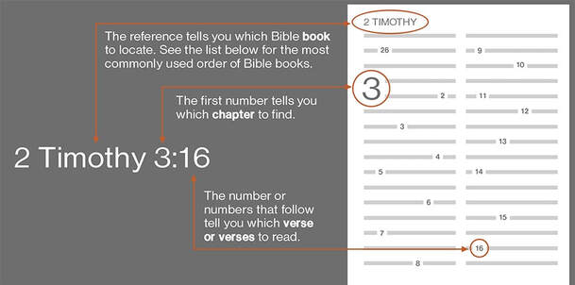

As we explore the New Testament this year, it is good for us to have a reminder of how the Bible is organized and how to look up a Scripture verse or passage (group of verses). Here is a short description of how the books of the Bible are arranged and another explanation of how to look something up in the Bible.
https://www.loyolapress.com/catholic-resources/scripture-and-tradition/catholic-bible-study/articles/does-the-bible-have-anything-to-do-with-my-life/

Faithful Citizenship

Although we are all tired of all the political ads, it is essential that we Catholics exercise our rights and responsibilities to participate in the governance of our nation, state, and local communities. Here is a video from the United States Conference of Catholic Bishops (USCCB) which explains our role as Catholic citizens and calls us to register to vote, inform our consciences, and make informed choices.

Our parish will offer an opportunity for individuals to register to vote and learn about options for voting after the Masses on the weekend of September 19 and 20.

To discover more about our call to participate in the public square, please visit the USCCB's Faithful Citizenship page.

Desserts
Focus on a Saint:

September 21 - St. Matthew

The Feast Day of St. Matthew is September 21. Matthew was a tax collector, and in the time of Jesus, most tax collectors cheated people and were shunned. In calling Matthew to be one of his apostles, Jesus taught that he came to serve everyone, including sinners. Find Matthew 9:11-13 in your Bible and read about Jesus calling Matthew yourself. Matthew is the patron saint of accountants, actors, bankers, bookkeepers, tax collectors, and taxi drivers.​

St. Matthew Resources

https://www.youtube.com/watch?v=SKlpNLRadAo

Our Catholic Traditions:
The Cross

September 14 is the Feast of the Exaltation of the Holy Cross. To discover more about this feast: https://www.franciscanmedia.org/exaltation-of-the-holy-cross/ and https://catechistsjourney.loyolapress.com/2020/09/pop-up-catechesis-whats-in-your-trophy-case/

The cross is an important symbol for Christians because it reminds us of the love Jesus has for us, a love so great that he gave his life for us. Crosses come in many shapes and sizes, and are used in many decorative ways. But it is important to remember that the cross is a symbol of sacrifice, and that we are called to sacrifice for others like Jesus did.

A crucifix is a cross with an image of Jesus on it. Sometimes that image is of Jesus' crucified body, and sometimes it is of Jesus' resurrected body. A cross is just that -- the cross symbol alone, without an image of Jesus.

This feast day is a good day to practice making the Sign of the Cross with young ones. Here is a simple cross craft that could be fun to do together.

https://www.momontimeout.com/stained-glass-cross-easter-craft/

September 29 is the Feast of the Archangels -- Michael, Gabriel, and Raphael. Before the liturgical calendar of the Church was revised in 1969, September 29 was simply the Feast of St. Michael. In Europe, many customs and traditions for celebrating the day, known as Michaelmas, developed. Perhaps your household can use some of these traditions to mark the feast day this year;
- One custom is to roast a goose, with carrots, for the main meal of the day. Since goose is harder to come by in the United States, why not roast a chicken with onions and potatoes and carrots?
- Legend says that when Michael drove Satan out of Heaven, Satan fell into a thicket of blackberry bushes and cursed them. A custom arose that said all the blackberries had to be harvested by Michaelmas, before the devil could curse them. Have some blackberry preserves on your breakfast toast, or make a blackberry dessert to go with your evening meal.
- Place a St. Michael holy card or another image of St. Michael in your prayer space.
- St. Michael is the patron saint of soldiers, doctors, grocers, and the police. Thank those people in your life who work in those professions, and wish them -- as well as the Michaels in your life -- a happy feast day!

Liturgical Year Connections:
September 29 marks the Feast of the Archangels, Gabriel, Michael, and Rafael.

Adults and teens might want to hear a podcast about the three archangels here.

Below is a traditional prayer that parents might want to help their young children learn. ​
Include a Guardian Angel prayer.

https://www.franciscanmedia.org/saints-michael-gabriel-and-raphael/

Faith in Action:
Share School Supplies

As this unusual school year unfolds, children and youth will continue to need school supplies, whether they are learning at home, at school, or both. While you are out shopping, or ordering online, buy some extra pencils, pens, crayons, folders, markers, etc. for families who are struggling during the pandemic. Watch for an announcement later this month about where and when to drop them off, and we will get them to families in need. Thank you for showing the love of Jesus to families in need by sharing your resources!

For Fun:
Movie review of Surfer Girl
September’s for fun is a movie review. The movie Soul Surfer is a wonderful family movie about strength, determination, faith, and family love. The movie is based on the autobiography by Bethany Hamilton. Bethany’s story is of determination and faith after she loses her arm in a shark attack and is determined to get back to being a competition surfer.
Recipe: Happy Family
Our recipe for this month is Happy Family. Join us in making stir-fry for your family meal before faith formation. You can try a favorite stir-fry recipe or we challenge you to post your favorite recipe on our facebook and instagram page post.
https://iowagirleats.com/broccoli-beef-recipe/

